From CT Images to Optimal Screw Configuration: A Comparative Study of Metaheuristic Algorithms for Cortical Bone Trajectory Screw Placement
Yi-Rou CHOU^{1,2,a)} Furen XIAO^{1,b)} Ming-Hong CHEN^{3,c)}

Abstract
Identifying an optimal seven-dimensional configuration for Cortical Bone Trajectory (CBT) screw placement from preoperative CT images is a complex optimization challenge. Our previous Particle Swarm Optimization (PSO) framework achieved outstanding accuracy, successfully generating bilateral trajectories (two screws per vertebra) in a commendable 88 seconds. To build upon this milestone and explore new algorithmic possibilities, in this study, we comprehensively evaluate three distinct optimization strategies: Nelder-Mead (NM) representing local simplex search, alongside PSO and Differential Evolution (DE) as global metaheuristics. Evaluated across 30 independent trials (targeting the L5 vertebra across 10 specific patients), results indicate that while NM offers rapid calculation, it struggles with local optima. Conversely, DE successfully bridges the gap, maintaining the high placement accuracy of PSO while significantly reducing the average computation time to around 48 seconds (a ~45% reduction). Our findings highlight DE as the superior algorithmic engine for balancing speed and robustness in automated surgical planning.

Introduction
Cortical bone trajectory (CBT) screw fixation offers a robust alternative to traditional pedicle screw constructs, maximizing pullout strength in osteoporotic bone through a medial-to-lateral and caudal-to-cephalad path [1]. However, identifying the optimal seven-dimensional configuration (entry coordinates, azimuth angle, altitude angle, and screw dimensions) that maximizes cortical engagement while strictly avoiding neurovascular breach is computationally demanding and highly patient-specific.

In our previous work [2], we established a computer-assisted planning framework utilizing Particle Swarm Optimization (PSO) to automate this process [3]. By integrating CT-derived Hounsfield Unit (HU) data, the system successfully achieved density-aware trajectory planning. While PSO delivers highly accurate and robust screw placements, its computational cost—averaging approximately 88 seconds per bilateral trajectories (two screws per vertebra).
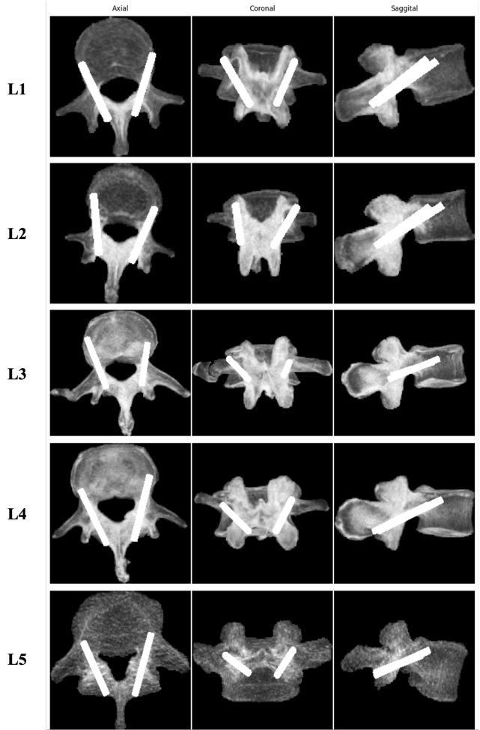
Fig. 1 Representative cortical bone trajectory planning results for lumbar vertebrae (L1–L5)
To address this limitation and accelerate the automated planning pipeline, this study systematically compares three distinct optimization strategies: Nelder-Mead (NM) as a representative local simplex search, alongside PSO and Differential Evolution (DE) as global metaheuristics [4],[5]. We formulate CBT screw placement as a high-dimensional optimization problem to evaluate which algorithmic engine best balances computational speed and anatomical safety.
Evaluated across 30 independent trials targeting the L5 vertebra in 10 patients, our results reveal a crucial performance dichotomy. While NM offers rapid execution, its susceptibility to local optima compromises placement reliability. Conversely, DE successfully bridges the performance gap: it maintains the high placement quality and robustness of PSO while reducing computation time to an average of 48 seconds (a 45% reduction). These findings highlight DE as a superior choice for advancing high-efficiency, image-guided surgical planning.

Method

Dataset and Preprocessing
This study utilized the COLONOG subset of the publicly available CTSpine1K dataset due to its near-complete lumbar coverage [6]. Preprocessing of the expert-annotated lumbar vertebrae involved resampling to an isotropic resolution of $0.5×0.5×0.5 {mm}^{3}$ to preserve fine anatomical details, followed by affine normalization to a consistent coordinate frame. A binary vertebral mask was generated for each vertebra to define the region of interest. 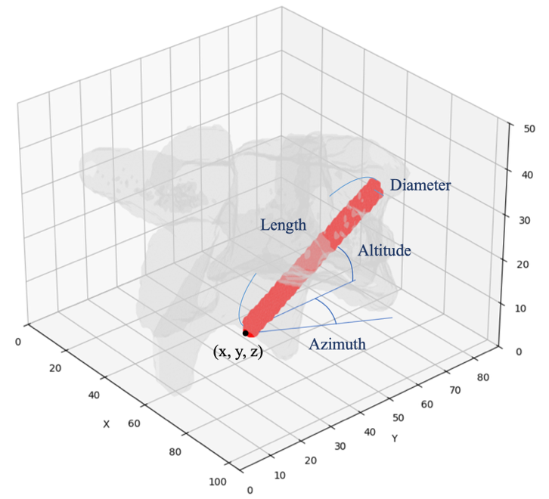
Fig. 2 Illustration of the seven parameters optimized in our framework.

Multi-Algorithm Optimization Framework
Each CBT screw was modeled as a 3D cylinder. The framework optimizes seven parameters per screw: entry coordinates $(x, y, z)$,$azimuth(θ)$, $azimuth(∅)$, and clinically discrete sizes for diameter and length. To systematically evaluate efficiency, we compared three distinct optimization engines bilaterally on L5 vertebrae:
- Particle Swarm Optimization (PSO) as a baseline global metaheuristic.
- Differential Evolution (DE) for potentially accelerated global search via mutation and crossover.
- Nelder-Mead (NM) representing a local simplex search baseline. Vertebral Orientation Calibration
To ensure a fair comparison, the maximum number of objective function evaluations (NFEs) was fixed at 7,000 across all algorithms (e.g., 100 iterations with a population size of 70 for PSO/DE, and 7,000 iterations for NM).

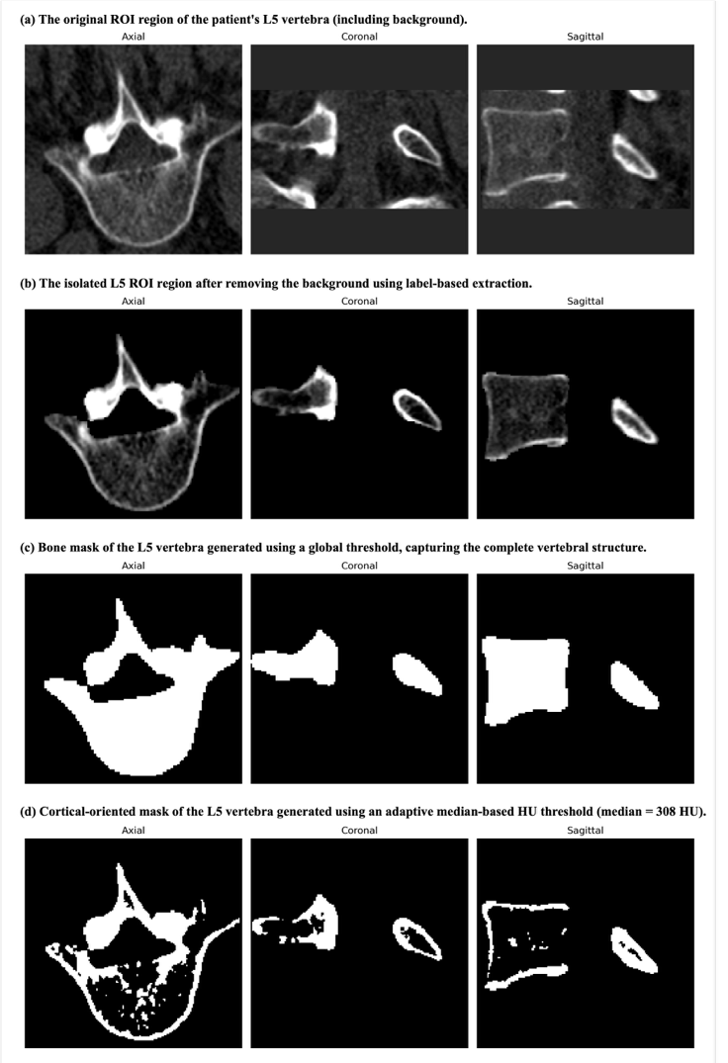
Fig. 3 Visualization of the preprocessing and mask generation pipeline for the L5 vertebra.

Adaptive Cortical Masking
As shown in Fig. 3, we incorporated bone quality using an adaptive cortical-oriented mask. Rather than using a fixed global threshold, each vertebra was thresholded at its own median HU value (cohort median: 280 HU), retaining the higher-density half of the voxels as a proxy for cortical bone. This effectively accounts for inter-subject and inter-scanner variability.

Objective Function and Constraints
The multi-objective loss function $F$ maximizes cortical engagement while penalizing unsafe trajectories:
$F={-(λ}_{1}S_{cortical}-λ_{2}S_{null}-λ_{3}S_{coll}- P_{min}-P_{inters})$
Here, $S_{cortical}$ measures voxel overlap with the cortical mask. Penalties include $S_{null}$ (extrusion outside the bone mask) and $S_{coll}$ (contralateral collision). $P_{min}$ penalizes insufficient cortical engagement (<100 voxels), while $P_{inters}$uses a 3D Bresenham’s algorithm to penalize trajectories exceeding two cortical boundary intersections.

Evaluation Metrics
To quantitatively assess the quality and safety of the planned trajectories, we defined three volumetric metrics:
- Vertebral Bone Score (%): Calculated as the percentage of the screw's volume overlapping with the entire vertebral bone mask. This serves as a primary indicator of anatomical safety (values < 100% indicate a potential cortical breach).
- Cortical Bone Score (%): Calculated as the percentage of the screw's volume specifically overlapping with the high-density cortical-oriented mask.
- Cortical/Vertebral Ratio (C/V ratio): The ratio of the Cortical Bone Score to the Vertebral Bone Score. A higher ratio signifies that a greater proportion of the engaged bone is dense cortical bone, which biomechanically correlates with enhanced screw pullout strength in osteoporotic patients.

Implementation Details
The automated pipeline was implemented in Python utilizing SimpleITK and NiBabel for image processing [7], [8]. The cylindrical screw projection, overlap scoring, and multi-algorithm evaluation were accelerated via PyTorch tensor operations. All experiments were conducted using an NVIDIA A40 GPU and 256 GB of system memory.
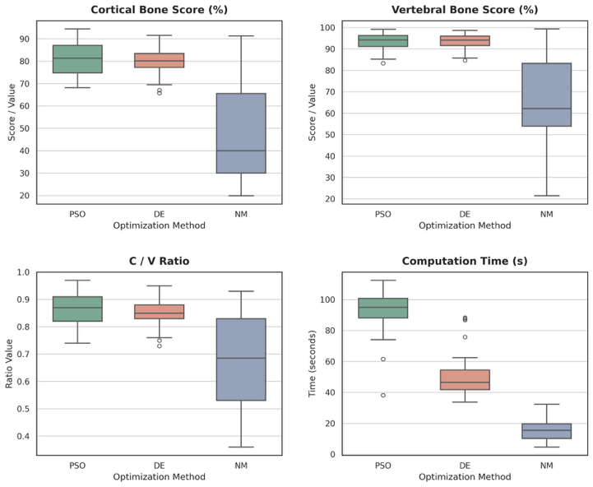
Fig. 4 Efficiency and robustness evaluation of optimization algorithms in 7D configuration space.
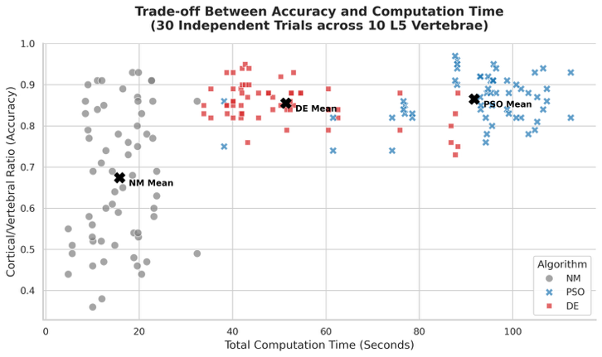
Fig. 5 Trade-off Between Accuracy and Computation Time (30 Independent Trials across 10 L5 Vertebrae).

Results and Discussion
To evaluate the algorithmic performance, each of the three optimization methods (NM, PSO, and DE) was executed bilaterally on the L5 vertebrae of 10 patients. To account for the stochastic nature of metaheuristics, three independent repetitions were performed per trajectory, yielding a total of 30 trials per algorithm.

Optimization Performance and Computational Efficiency
Fig. 4 illustrates the performance distribution across four key metrics: Cortical Bone Score (%), Vertebral Bone Score (%), C / V Ratio, and Total Computation Time. The results reveal a distinct performance dichotomy between local and global search strategies in this highly constrained 7D space.
The Nelder-Mead (NM) simplex method demonstrated the fastest execution time (median < 20 seconds) but failed to provide clinically acceptable trajectories. It exhibited the lowest median scores and severe variance in both Cortical Bone Overlap and Cortical/Bone Ratio. This instability indicates that the non-convex, heavily penalized HU-density landscape causes the purely local NM search to prematurely converge into suboptimal local minima.
Conversely, both global metaheuristics (PSO and DE) demonstrated exceptional robustness and accuracy. PSO achieved a high median Cortical/Bone Ratio (~0.87) with tight variance, confirming its reliability. However, its computational cost was the highest, averaging approximately 88–95 seconds per trajectory.
Differential Evolution (DE) emerged as the optimal solution. It matched, and in some metrics slightly exceeded, the placement quality of PSO (median Cortical Bone Overlap > 80%, median Total Bone Overlap > 93%). Crucially, DE achieved this high-fidelity geometric accuracy while cutting the computation time by nearly half, averaging approximately 48 seconds per trajectory.

Quantitative Trade-offs
As summarized in Table 1, analyzing the mean performance metrics reveals a distinct trade-off between computational efficiency and anatomical safety. The Nelder-Mead (NM) method, while offering the fastest average execution time (14.58 s), fails to meet clinical safety standards. It suffers from a severely low Vertebral Bone Score (62.34%), indicating frequent and severe cortical breaches as the local search prematurely converges into unsafe local minima.
Conversely, the global search strategies (PSO and DE) effectively navigate the constrained 7D space to secure safe and dense bone purchase. The baseline PSO achieves the highest safety (Vertebral Bone Score: 95.12%) and fixation strength (Cortical/Vertebral Ratio: 0.87), but requires an average of 91.24 seconds per trajectory. Differential Evolution (DE) emerges as the optimal solution, bridging this performance gap. It maintains a highly comparable Vertebral Bone Score (93.45%) and Cortical/Vertebral Ratio (0.85), while successfully reducing the computation time to 48.86 seconds—a ~45% acceleration over PSO. This establishes DE as a highly efficient and robust engine for automated trajectory planning.

Clinical Implications
In automated surgical planning, robustness is non-negotiable — a rapid algorithm that risks cortical breach (as seen with NM) is clinically unacceptable. By upgrading from PSO to DE, our framework achieves a favorable trade-off: preserving the density-aware precision required for safe CBT screw placement while reducing computation time by ~45%. This efficiency bridges the gap between complex voxel-level optimization and the demands of real-time clinical deployment.

Conclusions
This study presented a fully automated trajectory planning framework for Cortical Bone Trajectory (CBT) screw placement, comparing three optimization algorithms — Nelder-Mead (NM), Particle Swarm Optimization (PSO), and Differential Evolution (DE) — utilizing an adaptive HU-based cortical mask for density-aware geometric optimization.
While the local search approach (NM) proved unacceptably unstable, and PSO was robust but computationally heavy, DE emerged as the definitive solution. DE maintained the high-fidelity geometric and density precision required to prevent cortical breaches, while reducing average computation time by 45% (to approximately 48 seconds per trajectory). These results position DE as an efficient and reliable engine for automated spinal surgical planning, bringing patient-specific voxel-level optimization closer to real-time clinical workflows.

Acknowledgment
The authors would like to thank Prof. Tomoya Sakai of Nagasaki University for his valuable guidance and support during this research. The authors also gratefully acknowledge NVIDIA Corporation for GPU resources provided through the NVIDIA Academic Hardware Grant Program, which supported the computational experiments in this work.

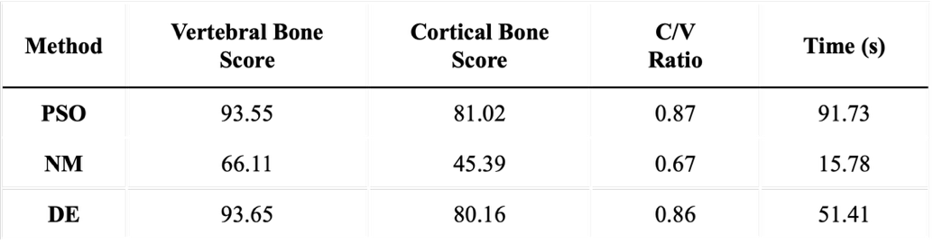
Table 1 Quantitative Performance Comparison of Optimization Algorithms.

References
- B. G. Santoni, R. A. Hynes, K. C. McGilvray, G. Rodriguez-Canessa, A. S. Lyons, M. A. Henson, W. J. Womack, and C. M. Puttlitz, "Cortical bone trajectory for lumbar pedicle screws," Spine J., vol. 9, no. 5, pp. 366–373, May 2009, doi: 10.1016/j.spinee.2008.07.008.
- Y. -R. Chou, F. Xiao and M. -H. Chen, "Automated Planning of Cortical Bone Trajectory: A Novel Technique for Pedicle Screw Placement Using Particle Swarm Optimization," 2025 Second International Conference on Artificial Intelligence for Medicine, Health and Care (AIxMHC), Taichung, Taiwan, 2025, pp. 258-259, doi: 10.1109/AIxMHC65380.2025.00054.J.
- J. Kennedy and R. Eberhart, "Particle swarm optimization," in Proc. IEEE Int. Conf. Neural Networks, Perth, Australia, 1995, pp. 1942–1948.
- J. A. Nelder and R. Mead, "A simplex method for function minimization," The Computer Journal, vol. 7, no. 4, pp. 308–313, Jan. 1965, doi: 10.1093/comjnl/7.4.308.
- R. Storn and K. Price, "Differential evolution–a simple and efficient heuristic for global optimization over continuous spaces," Journal of Global Optimization, vol. 11, no. 4, pp. 341–359, Dec. 1997, doi: 10.1023/A:1008202821328.
- Y. Deng et al., "CTSpine1K: A large-scale dataset for spinal vertebrae segmentation in computed tomography," arXiv preprint, arXiv:2105.14711, 2021.
- Z. Yaniv, B. C. Lowekamp, H. J. Johnson, and R. Beare, "SimpleITK Image-Analysis Notebooks: a Collaborative Environment for Education and Reproducible Research," Journal of Digital Imaging, vol. 31, no. 3, pp. 290-303, 2018, doi: 10.1007/s10278-017-0037-8.
- M. Brett et al., "nipy/nibabel," Zenodo, doi: 10.5281/zenodo.592860.

¹ National Taiwan University, Taiwan
² Nagasaki University, Japan
³ Far Eastern Memorial Hospital, Taiwan
^{a)} r12458006@g.ntu.edu.tw, bb54926553@ms.nagasaki-u.ac.jp
^{b)} fxiao@ntu.edu.tw
^{c)} chen.minghong@gmail.com

